Wireframing New Pages

Christine Hodges

Rasmussen College

Author Note

This paper is being submitted on April 22nd, 2018 for Professor Darice Corey’s CIS3801 Fundamentals of Mobile Web Application Development Course.

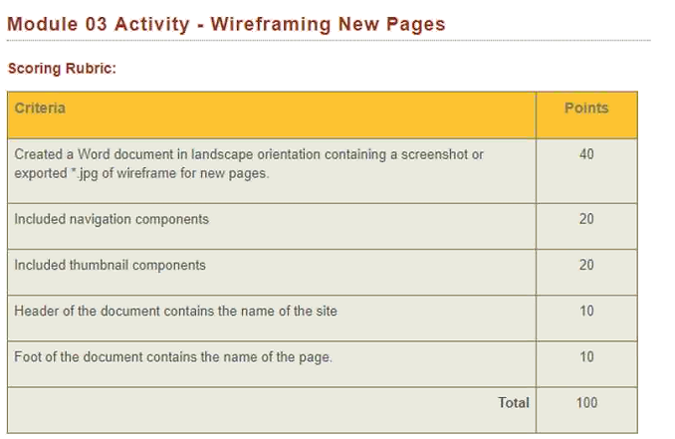

Feature’s Page Wireframe with grid system layout

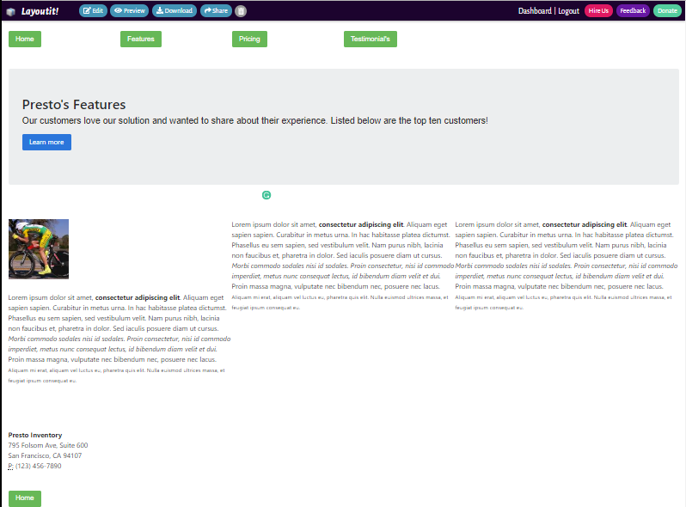

Testimonial’s Page Wireframe with grid system layout

